**1st scenario with screen shots for use case of “check in”:**

1. Chase, a front desk receptionist, meets with a customer who has already made reservation before coming to the restaurant. When he knows that the customer wants to check in, he clicks the “check in ” button in the main interface. 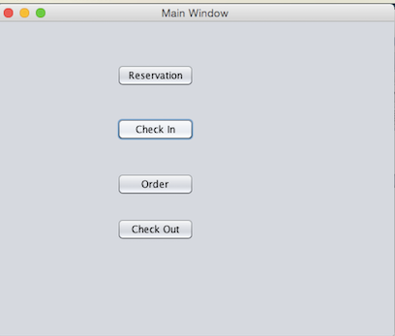

2. System displays a new interface to prompt receptionist to type last name of customer, cell phone number and group size.

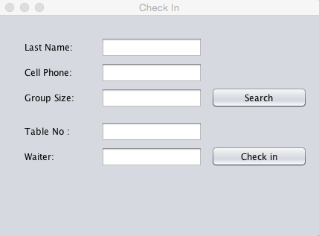

3. Waiter Chase types the information provided by costumer. He types “Chen” into “user name” text box, types “123-345-3232” into “cell phone” text box and types “4” into “group size” text box.

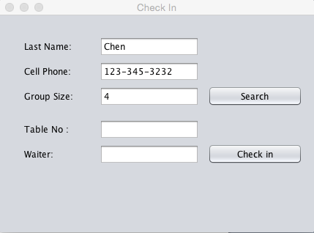

4. After Chase types the information provided by customer, he clicks “Search” button. And System will find out a record, which matches what he types in. As a result, interface will display “Table No:” 3 and “Waiter” David that are assigned to this customer.

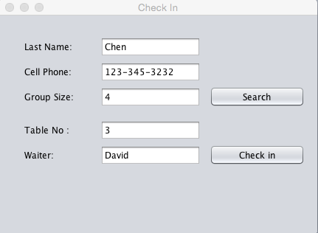

5. Waiter Chase clicks the “check in” button to complete it. The system will pop out a window showing “check in successfully” to confirm the process of check in is successful.

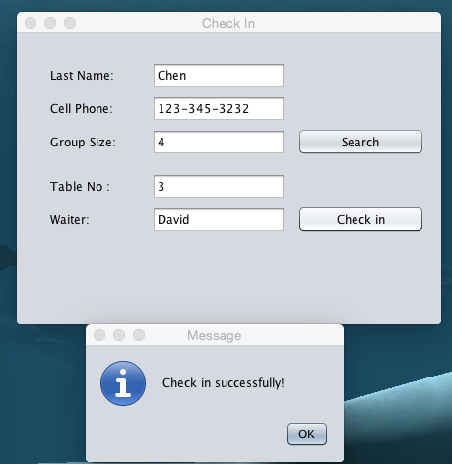

**2nd scenario with screen shots for use case of “check in”:**

1. Chase, a front desk receptionist, meets with a customer who has already made reservation before coming to the restaurant. When he knows that the customer wants to check in, he clicks the “check in ” button in the main interface. 

2. System displays a new interface to prompt receptionist to type last name of customer, cell phone number and group size.



3. Waiter Chase types the information provided by costumer. He types “Chen” into “user name” text box, types “123-345-3231” into “cell phone” text box by mistake and types “4” into “group size” text box.

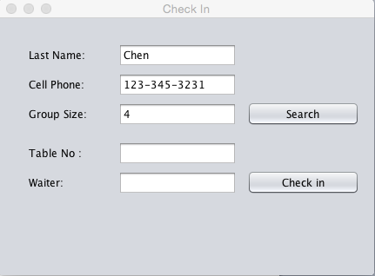

4. After Chase types the information provided by customer, he clicks “Search” button. And System will not find out a record, which can match what he types in. As a result, interface pop out a message box showing that “Invalid Information for Reservation ”.

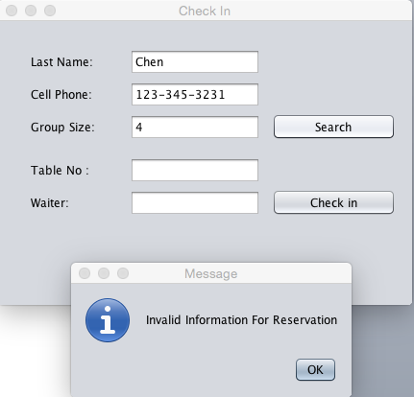

**Source Code of “Check in”:**

/*

* To change this license header, choose License Headers in Project Properties.

* To change this template file, choose Tools | Templates

* and open the template in the editor.

*/

package rms;

import javax.swing.JOptionPane;

/**

*

* @author Chase

*/

public class CheckinWindow extends javax.swing.JDialog {

/**

* Creates new form CheckinWindow

*/

public CheckinWindow() {

initComponents();

setTitle("Check In");

}

/**

* This method is called from within the constructor to initialize the form.

* WARNING: Do NOT modify this code. The content of this method is always

* regenerated by the Form Editor.

*/

@SuppressWarnings("unchecked")

// <editor-fold defaultstate="collapsed" desc="Generated Code">

private void initComponents() {

jLabel1 = new javax.swing.JLabel();

jLabel2 = new javax.swing.JLabel();

jLabel3 = new javax.swing.JLabel();

jLabel4 = new javax.swing.JLabel();

jLabel5 = new javax.swing.JLabel();

jTextField1 = new javax.swing.JTextField();

jTextField2 = new javax.swing.JTextField();

jTextField3 = new javax.swing.JTextField();

jTextField4 = new javax.swing.JTextField();

jTextField5 = new javax.swing.JTextField();

jButton1 = new javax.swing.JButton();

jButton2 = new javax.swing.JButton();

jLabel1.setText("Last Name:");

jLabel2.setText("Cell Phone:");

jLabel3.setText("Group Size:");

jLabel4.setText("Table No :");

jLabel5.setText("Waiter:");

jButton1.setText("Search");

jButton1.addMouseListener(new java.awt.event.MouseAdapter() {

public void mouseClicked(java.awt.event.MouseEvent evt) {

jButton1MouseClicked(evt);

}

});

jButton2.setText("Check in");

jButton2.addMouseListener(new java.awt.event.MouseAdapter() {

public void mouseClicked(java.awt.event.MouseEvent evt) {

jButton2MouseClicked(evt);

}

});

javax.swing.GroupLayout layout = new javax.swing.GroupLayout(getContentPane());

getContentPane().setLayout(layout);

layout.setHorizontalGroup(

layout.createParallelGroup(javax.swing.GroupLayout.Alignment.LEADING)

.addGroup(javax.swing.GroupLayout.Alignment.TRAILING, layout.createSequentialGroup()

.addGap(34, 34, 34)

.addGroup(layout.createParallelGroup(javax.swing.GroupLayout.Alignment.LEADING)

.addGroup(layout.createParallelGroup(javax.swing.GroupLayout.Alignment.LEADING, false)

.addComponent(jLabel4, javax.swing.GroupLayout.DEFAULT_SIZE, javax.swing.GroupLayout.DEFAULT_SIZE, Short.MAX_VALUE)

.addComponent(jLabel3, javax.swing.GroupLayout.DEFAULT_SIZE, javax.swing.GroupLayout.DEFAULT_SIZE, Short.MAX_VALUE)

.addGroup(layout.createParallelGroup(javax.swing.GroupLayout.Alignment.LEADING, false)

.addComponent(jLabel2, javax.swing.GroupLayout.DEFAULT_SIZE, javax.swing.GroupLayout.DEFAULT_SIZE, Short.MAX_VALUE)

.addComponent(jLabel1, javax.swing.GroupLayout.DEFAULT_SIZE, javax.swing.GroupLayout.DEFAULT_SIZE, Short.MAX_VALUE)))

.addComponent(jLabel5, javax.swing.GroupLayout.PREFERRED_SIZE, 63, javax.swing.GroupLayout.PREFERRED_SIZE))

.addGap(36, 36, 36)

.addGroup(layout.createParallelGroup(javax.swing.GroupLayout.Alignment.LEADING, false)

.addComponent(jTextField2, javax.swing.GroupLayout.PREFERRED_SIZE, 136, javax.swing.GroupLayout.PREFERRED_SIZE)

.addComponent(jTextField1, javax.swing.GroupLayout.PREFERRED_SIZE, 136, javax.swing.GroupLayout.PREFERRED_SIZE)

.addGroup(layout.createSequentialGroup()

.addComponent(jTextField3, javax.swing.GroupLayout.PREFERRED_SIZE, 136, javax.swing.GroupLayout.PREFERRED_SIZE)

.addPreferredGap(javax.swing.LayoutStyle.ComponentPlacement.UNRELATED)

.addComponent(jButton1, javax.swing.GroupLayout.DEFAULT_SIZE, javax.swing.GroupLayout.DEFAULT_SIZE, Short.MAX_VALUE))

.addComponent(jTextField4, javax.swing.GroupLayout.PREFERRED_SIZE, 136, javax.swing.GroupLayout.PREFERRED_SIZE)

.addGroup(layout.createSequentialGroup()

.addComponent(jTextField5, javax.swing.GroupLayout.PREFERRED_SIZE, 136, javax.swing.GroupLayout.PREFERRED_SIZE)

.addPreferredGap(javax.swing.LayoutStyle.ComponentPlacement.UNRELATED)

.addComponent(jButton2, javax.swing.GroupLayout.PREFERRED_SIZE, 129, javax.swing.GroupLayout.PREFERRED_SIZE)))

.addContainerGap(17, Short.MAX_VALUE))

);

layout.setVerticalGroup(

layout.createParallelGroup(javax.swing.GroupLayout.Alignment.LEADING)

.addGroup(layout.createSequentialGroup()

.addGap(29, 29, 29)

.addGroup(layout.createParallelGroup(javax.swing.GroupLayout.Alignment.BASELINE)

.addComponent(jLabel1, javax.swing.GroupLayout.DEFAULT_SIZE, javax.swing.GroupLayout.DEFAULT_SIZE, Short.MAX_VALUE)

.addComponent(jTextField1, javax.swing.GroupLayout.PREFERRED_SIZE, javax.swing.GroupLayout.DEFAULT_SIZE, javax.swing.GroupLayout.PREFERRED_SIZE))

.addPreferredGap(javax.swing.LayoutStyle.ComponentPlacement.RELATED)

.addGroup(layout.createParallelGroup(javax.swing.GroupLayout.Alignment.BASELINE)

.addComponent(jLabel2, javax.swing.GroupLayout.PREFERRED_SIZE, 28, javax.swing.GroupLayout.PREFERRED_SIZE)

.addComponent(jTextField2, javax.swing.GroupLayout.PREFERRED_SIZE, javax.swing.GroupLayout.DEFAULT_SIZE, javax.swing.GroupLayout.PREFERRED_SIZE))

.addPreferredGap(javax.swing.LayoutStyle.ComponentPlacement.RELATED)

.addGroup(layout.createParallelGroup(javax.swing.GroupLayout.Alignment.BASELINE)

.addComponent(jLabel3, javax.swing.GroupLayout.PREFERRED_SIZE, 28, javax.swing.GroupLayout.PREFERRED_SIZE)

.addComponent(jTextField3, javax.swing.GroupLayout.PREFERRED_SIZE, javax.swing.GroupLayout.DEFAULT_SIZE, javax.swing.GroupLayout.PREFERRED_SIZE)

.addComponent(jButton1, javax.swing.GroupLayout.PREFERRED_SIZE, 28, javax.swing.GroupLayout.PREFERRED_SIZE))

.addGap(18, 18, 18)

.addGroup(layout.createParallelGroup(javax.swing.GroupLayout.Alignment.BASELINE)

.addComponent(jLabel4)

.addComponent(jTextField4, javax.swing.GroupLayout.PREFERRED_SIZE, javax.swing.GroupLayout.DEFAULT_SIZE, javax.swing.GroupLayout.PREFERRED_SIZE))

.addGap(6, 6, 6)

.addGroup(layout.createParallelGroup(javax.swing.GroupLayout.Alignment.BASELINE)

.addComponent(jLabel5)

.addComponent(jTextField5, javax.swing.GroupLayout.PREFERRED_SIZE, javax.swing.GroupLayout.DEFAULT_SIZE, javax.swing.GroupLayout.PREFERRED_SIZE)

.addComponent(jButton2, javax.swing.GroupLayout.PREFERRED_SIZE, 28, javax.swing.GroupLayout.PREFERRED_SIZE))

.addContainerGap(93, Short.MAX_VALUE))

);

pack();

}// </editor-fold>

private void jButton1MouseClicked(java.awt.event.MouseEvent evt) {

if ((jTextField1.getText().equals("Chen") && jTextField2.getText().equals("123-345-3232") && jTextField3.getText().equals("4"))==true)

{jTextField4.setText("3");

jTextField5.setText("David");}

if ((jTextField1.getText().equals("Chen") && jTextField2.getText().equals("123-345-3232") && jTextField3.getText().equals("4"))==false)

{JOptionPane.showMessageDialog(null,"Invalid Information For Reservation");

}// TODO add your handling code here:

}

private void jButton2MouseClicked(java.awt.event.MouseEvent evt) {

// TODO add your handling code here:

if ((jTextField1.getText().equals("Chen") && jTextField2.getText().equals("123-345-3232") && jTextField3.getText().equals("4"))==true)

{JOptionPane.showMessageDialog(null,"Check in successfully!");}

}

/**

* @param args the command line arguments

*/

public static void main(String args[]) {

/* Set the Nimbus look and feel */

//<editor-fold defaultstate="collapsed" desc=" Look and feel setting code (optional) ">

/* If Nimbus (introduced in Java SE 6) is not available, stay with the default look and feel.

* For details see http://download.oracle.com/javase/tutorial/uiswing/lookandfeel/plaf.html

*/

try {

for (javax.swing.UIManager.LookAndFeelInfo info : javax.swing.UIManager.getInstalledLookAndFeels()) {

if ("Nimbus".equals(info.getName())) {

javax.swing.UIManager.setLookAndFeel(info.getClassName());

break;

}

}

} catch (ClassNotFoundException ex) {

java.util.logging.Logger.getLogger(CheckinWindow.class.getName()).log(java.util.logging.Level.SEVERE, null, ex);

} catch (InstantiationException ex) {

java.util.logging.Logger.getLogger(CheckinWindow.class.getName()).log(java.util.logging.Level.SEVERE, null, ex);

} catch (IllegalAccessException ex) {

java.util.logging.Logger.getLogger(CheckinWindow.class.getName()).log(java.util.logging.Level.SEVERE, null, ex);

} catch (javax.swing.UnsupportedLookAndFeelException ex) {

java.util.logging.Logger.getLogger(CheckinWindow.class.getName()).log(java.util.logging.Level.SEVERE, null, ex);

}

//</editor-fold>

/* Create and display the form */

java.awt.EventQueue.invokeLater(new Runnable() {

public void run() {

new CheckinWindow().setVisible(true);

}

});

}

// Variables declaration - do not modify

private javax.swing.JButton jButton1;

private javax.swing.JButton jButton2;

private javax.swing.JLabel jLabel1;

private javax.swing.JLabel jLabel2;

private javax.swing.JLabel jLabel3;

private javax.swing.JLabel jLabel4;

private javax.swing.JLabel jLabel5;

private javax.swing.JTextField jTextField1;

private javax.swing.JTextField jTextField2;

private javax.swing.JTextField jTextField3;

private javax.swing.JTextField jTextField4;

private javax.swing.JTextField jTextField5;

// End of variables declaration

}

**Scenario of use case “check out”**

1. When a costumer finishes dinner and wants to check out, the receptionist Chase choose “check out” in the main interface.

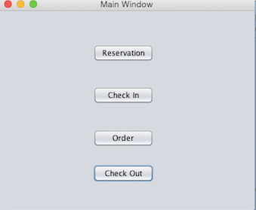

2. System displays a new interface to prompt receptionist to type table number.

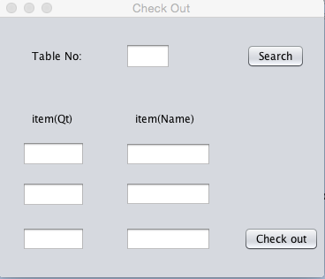

3. The receptionist will type this customer’s table Number that is 4 and click “Search” button.

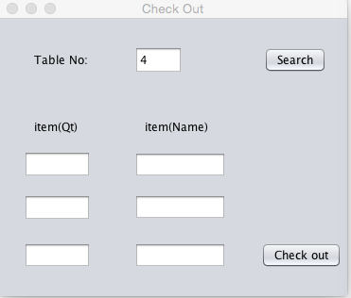

4. The system will display the order information of this customer like the item name as well as the item quantity corresponding to it.

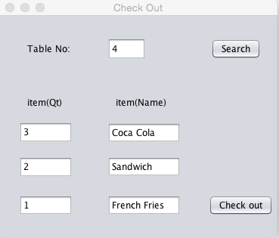

5. Then the receptionist clicks the “Check out” button and a message box will pop out showing the total price of the order.

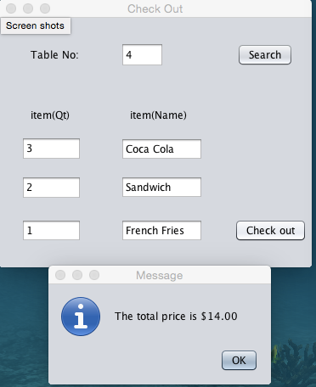

**The source code of “Check out”:**

/*

* To change this license header, choose License Headers in Project Properties.

* To change this template file, choose Tools | Templates

* and open the template in the editor.

*/

package rms;

import javax.swing.JOptionPane;

/**

*

* @author Chase

*/

public class CheckoutWindow extends javax.swing.JDialog {

/**

* Creates new form CheckoutWindow

*/

public CheckoutWindow() {

initComponents();

setTitle("Check Out");

}

/**

* This method is called from within the constructor to initialize the form.

* WARNING: Do NOT modify this code. The content of this method is always

* regenerated by the Form Editor.

*/

@SuppressWarnings("unchecked")

// <editor-fold defaultstate="collapsed" desc="Generated Code">

private void initComponents() {

jLabel1 = new javax.swing.JLabel();

jTextField1 = new javax.swing.JTextField();

jButton1 = new javax.swing.JButton();

jTextField2 = new javax.swing.JTextField();

jTextField3 = new javax.swing.JTextField();

jTextField4 = new javax.swing.JTextField();

jTextField5 = new javax.swing.JTextField();

jTextField6 = new javax.swing.JTextField();

jTextField7 = new javax.swing.JTextField();

jButton2 = new javax.swing.JButton();

jLabel2 = new javax.swing.JLabel();

jLabel3 = new javax.swing.JLabel();

jLabel1.setText("Table No:");

jButton1.setLabel("Search");

jButton1.addMouseListener(new java.awt.event.MouseAdapter() {

public void mouseClicked(java.awt.event.MouseEvent evt) {

jButton1MouseClicked(evt);

}

});

jButton1.addActionListener(new java.awt.event.ActionListener() {

public void actionPerformed(java.awt.event.ActionEvent evt) {

jButton1ActionPerformed(evt);

}

});

jTextField4.addActionListener(new java.awt.event.ActionListener() {

public void actionPerformed(java.awt.event.ActionEvent evt) {

jTextField4ActionPerformed(evt);

}

});

jButton2.setText("Check out");

jButton2.addMouseListener(new java.awt.event.MouseAdapter() {

public void mouseClicked(java.awt.event.MouseEvent evt) {

jButton2MouseClicked(evt);

}

});

jLabel2.setText("item(Qt)");

jLabel3.setText("item(Name)");

javax.swing.GroupLayout layout = new javax.swing.GroupLayout(getContentPane());

getContentPane().setLayout(layout);

layout.setHorizontalGroup(

layout.createParallelGroup(javax.swing.GroupLayout.Alignment.LEADING)

.addGroup(layout.createSequentialGroup()

.addGap(26, 26, 26)

.addGroup(layout.createParallelGroup(javax.swing.GroupLayout.Alignment.TRAILING)

.addComponent(jTextField2, javax.swing.GroupLayout.PREFERRED_SIZE, 71, javax.swing.GroupLayout.PREFERRED_SIZE)

.addGroup(layout.createParallelGroup(javax.swing.GroupLayout.Alignment.LEADING)

.addComponent(jTextField6, javax.swing.GroupLayout.Alignment.TRAILING, javax.swing.GroupLayout.PREFERRED_SIZE, 71, javax.swing.GroupLayout.PREFERRED_SIZE)

.addGroup(layout.createSequentialGroup()

.addGap(11, 11, 11)

.addGroup(layout.createParallelGroup(javax.swing.GroupLayout.Alignment.LEADING)

.addComponent(jLabel2)

.addComponent(jLabel1))))

.addComponent(jTextField4, javax.swing.GroupLayout.PREFERRED_SIZE, 71, javax.swing.GroupLayout.PREFERRED_SIZE))

.addGap(46, 46, 46)

.addGroup(layout.createParallelGroup(javax.swing.GroupLayout.Alignment.LEADING)

.addGroup(layout.createSequentialGroup()

.addComponent(jTextField1, javax.swing.GroupLayout.PREFERRED_SIZE, 51, javax.swing.GroupLayout.PREFERRED_SIZE)

.addPreferredGap(javax.swing.LayoutStyle.ComponentPlacement.RELATED, 86, Short.MAX_VALUE)

.addComponent(jButton1)

.addGap(22, 22, 22))

.addGroup(layout.createSequentialGroup()

.addGroup(layout.createParallelGroup(javax.swing.GroupLayout.Alignment.TRAILING, false)

.addComponent(jTextField7, javax.swing.GroupLayout.DEFAULT_SIZE, 97, Short.MAX_VALUE)

.addComponent(jTextField5)

.addComponent(jTextField3))

.addPreferredGap(javax.swing.LayoutStyle.ComponentPlacement.RELATED, javax.swing.GroupLayout.DEFAULT_SIZE, Short.MAX_VALUE)

.addComponent(jButton2)

.addContainerGap())

.addGroup(layout.createSequentialGroup()

.addGap(11, 11, 11)

.addComponent(jLabel3)

.addContainerGap(javax.swing.GroupLayout.DEFAULT_SIZE, Short.MAX_VALUE))))

);

layout.setVerticalGroup(

layout.createParallelGroup(javax.swing.GroupLayout.Alignment.LEADING)

.addGroup(layout.createSequentialGroup()

.addGap(29, 29, 29)

.addGroup(layout.createParallelGroup(javax.swing.GroupLayout.Alignment.BASELINE)

.addComponent(jLabel1)

.addComponent(jTextField1, javax.swing.GroupLayout.PREFERRED_SIZE, 29, javax.swing.GroupLayout.PREFERRED_SIZE)

.addComponent(jButton1))

.addGap(49, 49, 49)

.addGroup(layout.createParallelGroup(javax.swing.GroupLayout.Alignment.TRAILING)

.addComponent(jLabel2)

.addComponent(jLabel3))

.addGap(18, 18, 18)

.addGroup(layout.createParallelGroup(javax.swing.GroupLayout.Alignment.TRAILING)

.addComponent(jTextField2, javax.swing.GroupLayout.PREFERRED_SIZE, 28, javax.swing.GroupLayout.PREFERRED_SIZE)

.addComponent(jTextField3, javax.swing.GroupLayout.PREFERRED_SIZE, javax.swing.GroupLayout.DEFAULT_SIZE, javax.swing.GroupLayout.PREFERRED_SIZE))

.addGap(18, 18, 18)

.addGroup(layout.createParallelGroup(javax.swing.GroupLayout.Alignment.BASELINE)

.addComponent(jTextField5, javax.swing.GroupLayout.PREFERRED_SIZE, javax.swing.GroupLayout.DEFAULT_SIZE, javax.swing.GroupLayout.PREFERRED_SIZE)

.addComponent(jTextField4, javax.swing.GroupLayout.PREFERRED_SIZE, 28, javax.swing.GroupLayout.PREFERRED_SIZE))

.addGap(23, 23, 23)

.addGroup(layout.createParallelGroup(javax.swing.GroupLayout.Alignment.BASELINE)

.addComponent(jTextField6, javax.swing.GroupLayout.PREFERRED_SIZE, javax.swing.GroupLayout.DEFAULT_SIZE, javax.swing.GroupLayout.PREFERRED_SIZE)

.addComponent(jTextField7, javax.swing.GroupLayout.PREFERRED_SIZE, javax.swing.GroupLayout.DEFAULT_SIZE, javax.swing.GroupLayout.PREFERRED_SIZE)

.addComponent(jButton2))

.addContainerGap(30, Short.MAX_VALUE))

);

pack();

}// </editor-fold>

private void jTextField4ActionPerformed(java.awt.event.ActionEvent evt) {

// TODO add your handling code here:

}

private void jButton1ActionPerformed(java.awt.event.ActionEvent evt) {

// TODO add your handling code here:

}

private void jButton1MouseClicked(java.awt.event.MouseEvent evt) {

// TODO add your handling code here:

if (jTextField1.getText().equals("4"))

{jTextField2.setText("3");

jTextField3.setText("Coca Cola");

jTextField4.setText("2");

jTextField5.setText("Sandwich");

jTextField6.setText("1");

jTextField7.setText("French Fries");

}

}

private void jButton2MouseClicked(java.awt.event.MouseEvent evt) {

// TODO add your handling code here:

if (jTextField1.getText().equals("4"))

{JOptionPane.showMessageDialog(null,"The total price is $14.00");}

}

/**

* @param args the command line arguments

*/

public static void main(String args[]) {

/* Set the Nimbus look and feel */

//<editor-fold defaultstate="collapsed" desc=" Look and feel setting code (optional) ">

/* If Nimbus (introduced in Java SE 6) is not available, stay with the default look and feel.

* For details see http://download.oracle.com/javase/tutorial/uiswing/lookandfeel/plaf.html

*/

try {

for (javax.swing.UIManager.LookAndFeelInfo info : javax.swing.UIManager.getInstalledLookAndFeels()) {

if ("Nimbus".equals(info.getName())) {

javax.swing.UIManager.setLookAndFeel(info.getClassName());

break;

}

}

} catch (ClassNotFoundException ex) {

java.util.logging.Logger.getLogger(CheckoutWindow.class.getName()).log(java.util.logging.Level.SEVERE, null, ex);

} catch (InstantiationException ex) {

java.util.logging.Logger.getLogger(CheckoutWindow.class.getName()).log(java.util.logging.Level.SEVERE, null, ex);

} catch (IllegalAccessException ex) {

java.util.logging.Logger.getLogger(CheckoutWindow.class.getName()).log(java.util.logging.Level.SEVERE, null, ex);

} catch (javax.swing.UnsupportedLookAndFeelException ex) {

java.util.logging.Logger.getLogger(CheckoutWindow.class.getName()).log(java.util.logging.Level.SEVERE, null, ex);

}

//</editor-fold>

/* Create and display the form */

java.awt.EventQueue.invokeLater(new Runnable() {

public void run() {

new CheckoutWindow().setVisible(true);

}

});

}

// Variables declaration - do not modify

private javax.swing.JButton jButton1;

private javax.swing.JButton jButton2;

private javax.swing.JLabel jLabel1;

private javax.swing.JLabel jLabel2;

private javax.swing.JLabel jLabel3;

private javax.swing.JTextField jTextField1;

private javax.swing.JTextField jTextField2;

private javax.swing.JTextField jTextField3;

private javax.swing.JTextField jTextField4;

private javax.swing.JTextField jTextField5;

private javax.swing.JTextField jTextField6;

private javax.swing.JTextField jTextField7;

// End of variables declaration

}